Jerarquia

1. Color & Size

1. Layout

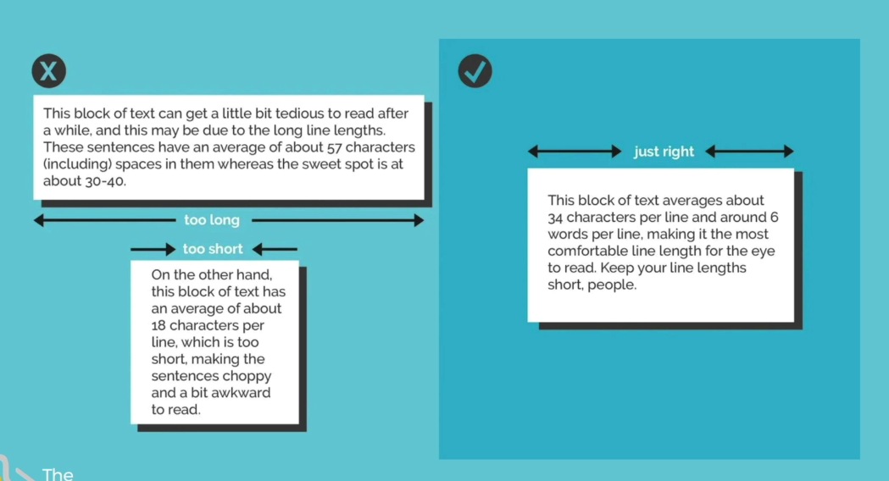

1. Alignment

1. White Space

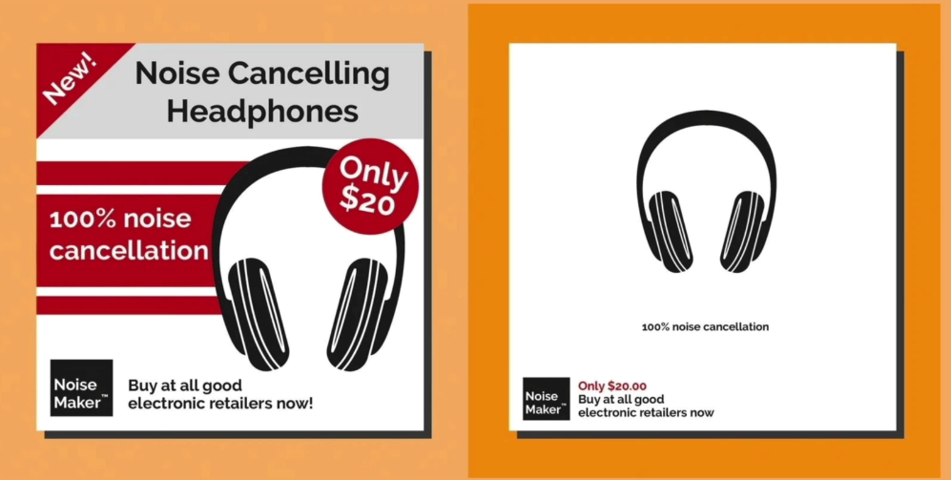

1. Audience

